What is Database Normalization?
Think of normalization as organizing a messy filing cabinet. In MySQL, normalization is the process of structuring your tables and columns to reduce data redundancy (repeating data) and improve data integrity (accuracy). Instead of stuffing everything into one giant spreadsheet-like table, you break it down into smaller, logical tables that relate to each other.

The Main Steps (Normal Forms)
We break normalization down into stages called Normal Forms (NFs). Each step builds on the previous one to make your database cleaner:
- 1st Normal Form (1NF): Ensure every column contains a single, indivisible value (no lists or comma-separated values in one cell) and every row is unique.
- 2nd Normal Form (2NF): Must be in 1NF, and all non-key columns must depend entirely on the primary key (no partial dependencies).
- 3rd Normal Form (3NF): Must be in 2NF, and there should be no transitive dependencies (non-key columns must depend directly on the primary key, not on other non-key columns).

A Simple Example
Imagine you run a store and store all your orders in a single, unnormalized table called Orders:
OrderID | CustomerName | CustomerEmail | Product | Price
101 | Alice Smith | alice@mail.com | Laptop | $1000
102 | Bob Jones | bob@mail.com | Phone | $500
103 | Alice Smith | alice@mail.com | Mouse | $25

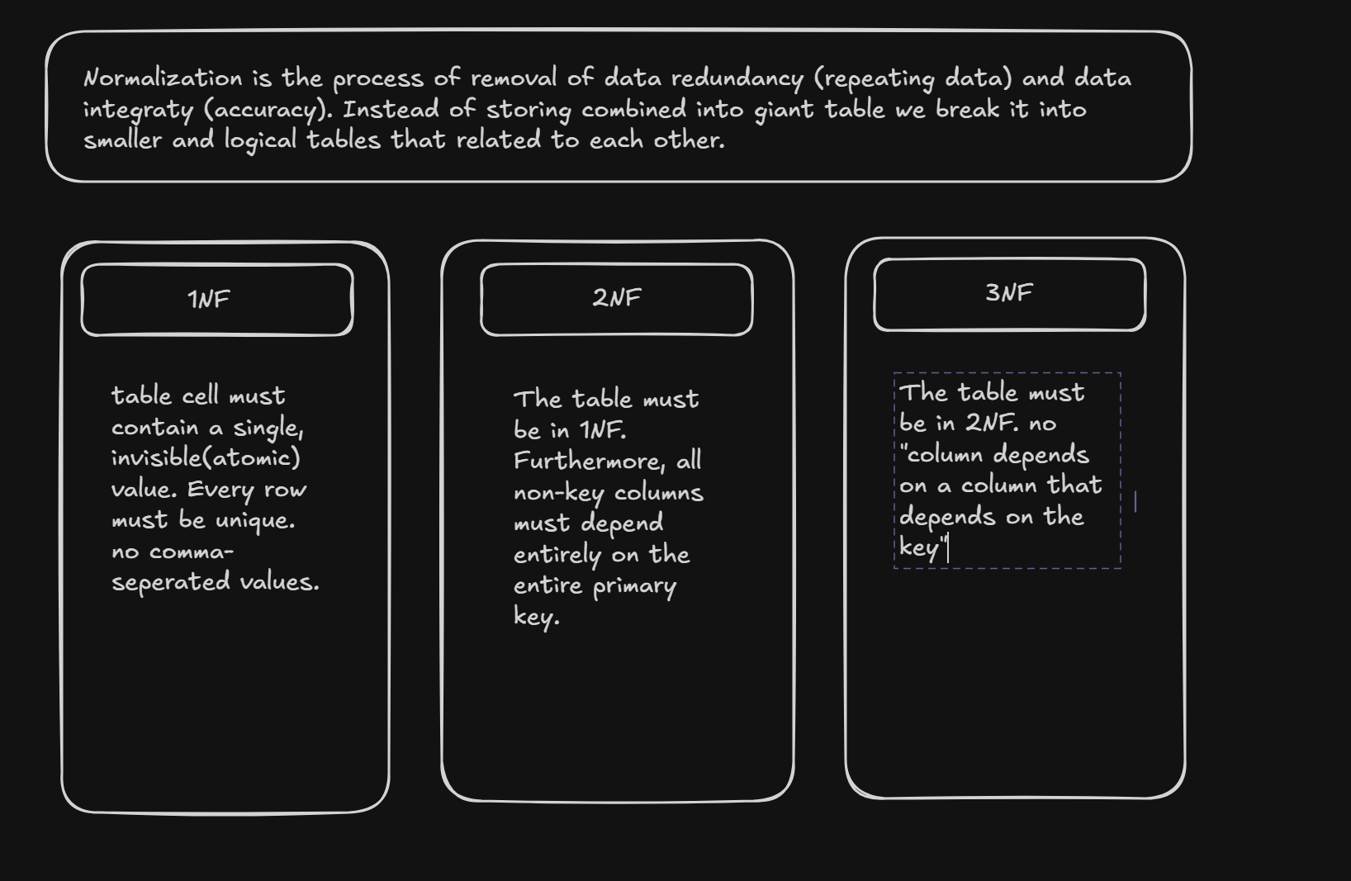
The Problem
Notice how Alice’s email (alice@mail.com) is repeated twice? If Alice changes her email, you have to update it in multiple places. If you miss one, your database suffers from data inconsistency.

The Normalized Solution
To fix this, we split the data into two separate, connected tables:
- Customers Table: Stores unique customer info (CustomerID, CustomerName, CustomerEmail).
- Orders Table: Stores order info and references the customer via CustomerID (OrderID, CustomerID, Product, Price).
Now, customer details are stored in only one place. If Alice changes her email, you update it once in the Customers table, and it automatically applies everywhere.
Let's walk through all the major Normal Forms (1NF through BCNF) using a single, step-by-step example so you can see how a messy table transforms into a clean, efficient database.

1st Normal Form (1NF): Atomic Values
- The Rule: Every table cell must contain a single, indivisible (atomic) value, and each column must contain values of a single type. No lists or comma-separated values allowed in one cell. Every row must also be unique.
Example of an Unnormalized Table (StudentCourses):
StudentID | StudentName | Courses
1 | Alice | Math, Physics
2 | Bob | Chemistry
Fixed in 1NF: (We split the multi-valued cell into separate rows)
StudentID | StudentName | Course
1 | Alice | Math
1 | Alice | Physics
2 | Bob | Chemistry

2nd Normal Form (2NF): No Partial Dependencies
- The Rule: The table must already be in 1NF. Furthermore, all non-key columns must depend entirely on the entire primary key. This only matters when you have a composite primary key (a key made of two or more columns).
The Problem: Look at a table where (StudentID, Course) is the composite primary key:
StudentID | Course | StudentName | Grade
1 | Math | Alice | A
1 | Physics | Alice | B
2 | Chemistry | Bob | A
- Issue: StudentName depends only on StudentID, not on the Course. Alice's name repeats every time she takes a new course.
Fixed in 2NF: (We split the table into two)
- Students Table: (StudentID, StudentName)
- Enrollments Table: (StudentID, Course, Grade)

3rd Normal Form (3NF): No Transitive Dependencies
- The Rule: The table must be in 2NF. Additionally, there must be no transitive dependencies. This means non-key columns must depend only on the primary key, not on other non-key columns (no "column depends on a column that depends on the key").

The Golden Rule of 3NF
- The Table must be in 2NF. (All non-key columns depend on the primary key).
- No Transitive Dependencies: A non-key column cannot depend on another non-key column.
  - In math terms: If $A \rightarrow B$ and $B \rightarrow C$, then $C$ depends transitively on $A$ through $B$. In 3NF, $C$ must be moved to its own table with $B$.

Step 1: The Problem (Violates 3NF)
Imagine a bookstore database where BookID is the primary key.
BookID | Title | PublisherID | PublisherName | PublisherCity
1 | Database Design | P101 | TechPress | New York
2 | Advanced SQL | P101 | TechPress | New York
3 | Python Basics | P102 | CodeBooks | San Francisco

Why does this violate 3NF?
Look closely at the columns:
- BookID (Primary Key) $\rightarrow$ determines $\rightarrow$ PublisherID
- PublisherID $\rightarrow$ determines $\rightarrow$ PublisherName and PublisherCity
Here, PublisherName and PublisherCity don't depend directly on the BookID. They depend on PublisherID, which happens to be in the same table.
The Issue: If TechPress changes its city from New York to Boston, you have to update multiple rows. If you miss one, your database has conflicting data (data inconsistency).

Step 2: The Solution (In 3NF)
To fix a transitive dependency, you split the dependent columns into their own table, using PublisherID as the bridge (Foreign Key).

Table 1: Books (Core book info)
BookID | Title | PublisherID
1 | Database Design | P101
2 | Advanced SQL | P101
3 | Python Basics | P102

Table 2: Publishers (Publisher details)
PublisherID | PublisherName | PublisherCity
P101 | TechPress | New York
P102 | CodeBooks | San Francisco

Why this is better:
- PublisherName and PublisherCity now live in one single place (Publishers table).
- If TechPress moves to Boston, you update one row, and the change instantly applies to all their books.
- Your database is now clean, efficient, and fully compliant with 3NF!

Boyce-Codd Normal Form (BCNF / 3.5NF): Strict 3NF
- The Rule: A stricter version of 3NF. For every functional dependency ($X \rightarrow Y$), $X$ must be a super key (a unique identifier or candidate key).
- In plain English: Even if a table is in 3NF, if a non-key column determines a part of a primary key, it violates BCNF.
The Problem: Imagine a table tracking students, courses, and the professors teaching them:
StudentID | Course | Professor
1 | Math | Dr. Smith
2 | Math | Dr. Smith
1 | Physics | Dr. Jones
- Rules here: A student and course together determine the professor. But Professor also determines the Course (Dr. Smith only teaches Math).
- Issue: Professor is determining Course, but Professor is not a candidate key (because a professor might teach multiple students).
Fixed in BCNF: (We separate professors and their courses)
- ProfessorCourses Table: (Professor, Course)
- StudentEnrollments Table: (StudentID, Course)

Why Database Normalization is Important
Normalization is the backbone of robust, scalable database design. Without it, databases quickly turn into unmanageable and error-prone messes. Here is why it is essential:
- Eliminates Data Redundancy: By storing information in a single place, you drastically cut down on storage waste, which keeps your database lightweight and fast.
- Prevents Data Anomalies: It stops three major headaches:
  - Update Anomalies: Having to update a value (like a user's email) in hundreds of duplicate rows instead of just one.
  - Insertion Anomalies: Being unable to add new data because mandatory fields from an unrelated entity are missing.
  - Deletion Anomalies: Accidentally losing critical business records because you deleted a row that bundled multiple types of information together.
- Ensures Data Integrity: With a single source of truth, your applications, reports, and analytics will always display accurate and consistent information.

Real-World Applications
You will find database normalization applied across virtually every industry that relies on structured data:
- E-Commerce Platforms (e.g., Amazon, Shopify): Separate tables for customers, products, orders, and payments ensure that a product's price or a customer's shipping address isn't awkwardly duplicated across every single transaction history.
- Banking & Financial Systems: Account balances, transaction logs, and customer profiles must be strictly normalized to prevent financial discrepancies and protect audit trails.
- Healthcare Systems: Patient records, doctors, prescriptions, and hospital visits are carefully normalized to maintain strict data accuracy, compliance, and patient safety.
In SQL and database design, a transitive dependency occurs when a non-key column depends on another non-key column, rather than depending directly on the primary key. [1, 2]
Mathematically, it follows the transitive property: [1]
- If column A determines B (A → B)
- And column B determines C (B → C)
- Then A indirectly determines C (A → C) [1, 2]
If A is the primary key, C has a transitive dependency on A through the intermediate column B. [1, 2]

📊 Real-World Example
Consider an Employees table with the following columns: [1]
Employee_ID (Primary Key) | Employee_Name | Department_ID | Department_Name
101 | Alice | D01 | Human Resources
102 | Bob | D02 | Engineering
103 | Charlie | D01 | Human Resources
Why this contains a transitive dependency:
- Employee_ID determines Department_ID (Each employee is assigned to a specific department code). [1]
- Department_ID determines Department_Name (The department name belongs to the department code, not the individual person). [1]
- Therefore, Employee_ID indirectly determines Department_Name. [1, 2]
Because Department_Name (a non-key column) depends on Department_ID (another non-key column), a transitive dependency exists. [1]

⚠️ Why Transitive Dependencies Are Bad
Keeping transitive dependencies in a single table causes major data integrity issues known as database anomalies: [1, 2]
- Data Redundancy: The string "Human Resources" is repeated unnecessarily for every employee in that department. [1, 2]
- Update Anomalies: If the department changes its name to "People Operations", you must update multiple rows. Missing a row results in inconsistent data. [1, 2]
- Insertion Anomalies: You cannot create a new department in the database until you hire at least one employee to anchor the row. [1]
- Deletion Anomalies: If Bob leaves the company and you delete his row, you accidentally wipe out the existence of the "Engineering" department from your system. [1]

